Biology 1200: Principles of Biology II
Section xxx, Spring 2025

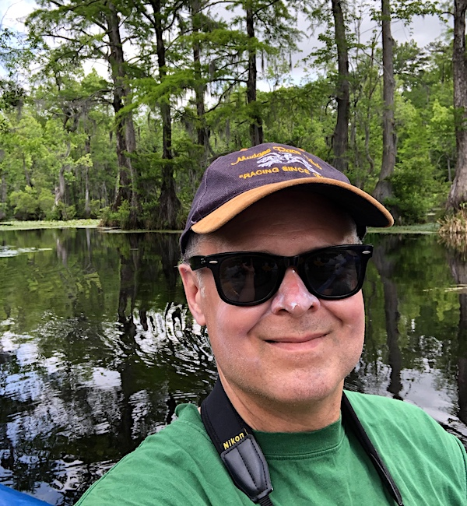
INSTRUCTOR: Dr. Jeff McKinnon
Lectures: T, Th, 9:30-10:45am, TBA
Office Hours: T 1:00 – 3:30pm; F 3:00 – 5:30pm; (or) by appointment
Office: LSBB 3420, https://ecu.webex.com/join/mckinnonj
Phone: 252-328-5258
Website: http://canvas.ecu.edu
email: mckinnonj@ecu.edu
Teaching Assistant: TBA
Text: Biology2e, Avissar et al. 2018, (Recommended) Biology from OpenStax,
ISBN-10: 1-947172-52-2,
https://openstax.org/details/books/biology-2e
Note: I do not rely heavily on a text.
Optional: Our Ancient Lakes: A Natural History. McKinnon, J.S. 2023, MIT Press. The course is not designed around this (or any) book but many of the same topics are covered for the evolution and conservation sections of the course, some biodiversity and ecology as well. Since I wrote the book, it takes the same approach I do.
Prerequisites: Biol 1100, 1101.

Course overview:
Approach: I hope to connect you to ideas, findings and experiences that will help you in your future studies and career, will help you be a better citizen of our nation and planet, and will stay with you a good while. I am enthusiastic about the study of Biology and will do my best to make the course interactive and engaging.
We will be using SimBio simulations and other online resources—in previous years, students found them very useful learning aids. These have a cost, less than ~$40 in total; I will provide ordering information. Based on student input, I concluded it was more valuable, and less expensive, for you to purchase these than a textbook. We will also use quizlets that previous Biology students and I have developed to make learning local biodiversity easy and enjoyable—and to familiarize you more directly with the 36th Global Biodiversity Hotspot, our own N American Coastal Plain.
My priorities: I am interested in helping you learn and succeed. I am obliged to evaluate your work and generate a grade (I recognize how important that is for all involved), but I am much more interested in helping you learn about Biology and start your career.
Learning Outcomes:
Students are expected to master the following four Natural Sciences and Course Specific student learning outcomes (Natural Sciences Competency = “SCC.”) and a fifth specific to this section:
- Evaluate current medical and environmental issues using knowledge of population biology, microevolution and ecological processes.
- Analyze and interpret organismal, population, and environmental data using the scientific method to develop and test hypotheses.
- Appraise the scope of current models of microevolution and population regulation based on the analysis of a diverse array of experimental and observational evidences.
- Explain how evolutionary biology and ecological theory relate to loss of biodiversity and climate change.
- Learn to recognize and identify common species of the most visible local biodiversity, birds (based on song and appearance) and trees.

These support:
Natural Sciences General Education Competency
Courses in the Natural Sciences engage students with subjects that aim to answer fundamental questions about the structure and function of the complex systems that constitute the physical universe. Students learn to seek knowledge for its own sake as well as for its application, and to understand the relation of technological progress to advances made in the Natural Sciences. Courses in the Natural Sciences further student understanding of the scientific method. This prepares them for further study in technology or basic science. Students learn the connection between successful interdisciplinary scholarship and the knowledge provided by the Natural Sciences. Courses in the Natural Sciences initiate the development of the knowledge and skills students need to become broadly informed, to participate in interdisciplinary scholarship, and to be successful in their professional specialization.

Natural Sciences General Education Student Learning Outcomes
The following program learning outcomes define the Natural Science Competency.
Students who have completed the General Education Natural Sciences requirements can:
- Apply discipline-specific knowledge to explain natural phenomena and scientific problems.
- Use discipline-specific methods to test a hypothesis by collecting, analyzing and interpreting data and communicate the results.
- Describe the scope and limits of science and how scientific inquiry is based on investigation of evidence from the natural world.
- Describe how scientific data and advances in science relate to societal issues.
Course Delivery:
This course will take place through lectures, which I will strive to make interactive. Assignments, quizzes and exams will be offered through Canvas and SimBio.
Please let me know by Thursday Jan. 16, 11:59pm if the exam schedule will present any problems for you. If an issue or other obligation arises later, please let me know immediately.
Computer and internet requirements: Students will need to access high-speed internet using computers to complete course assignments, and especially for exams; exams will be taken in class on a laptop. Equipment—including computers, webcams, headsets, and hotspots—is available for checkout at both ECU libraries:
• Equipment Available for Checkout from the main campus library (link)
• Equipment Available for Checkout from Laupus Library (link)
Plan ahead. If you have last minute tech issues that could have been anticipated, a second chance is unlikely. Keep laptop batteries charged and bring an adaptor!

Course Communication:
Contacting Me:
• When e-mailing, write in sentences with appropriate punctuation and give your first and last names (will generally reply by the next workday, usually faster).
• If you wish to speak with me, by phone or WebEx during office hours, you should schedule an appointment in advance via e-mail. But if I have not been scheduled I will also meet with little notice during office hours (e-mail [preferably] me or just show up in my webex room—I should be there or receive notification).

Contacting Classmates:
There might be times that you need to contact classmates directly. Please always be polite and be sensitive of cultural or personal differences.

Grading Policy and Exams:

Grades for this class will be assigned using a 10-point system approximately as follows:
Grade Points 10-Point Scale
A 4.0 93-100
A- 3.7 90-92.9
B+ 3.3 87-89.9
B 3 83-86.9
B- 2.7 80-82.9
C+ 2.3 77-79.9
C 2 73-76.9
C- 1.7 70-72.9
D+ 1.3 67-69.9
D 1 63-66.9
D- .7 60-62.9
F 0 0-59.9

Grades will be assessed by:
Mid-term lecture exam 1 10
Mid-term lecture exam 2 12
Mid-term lecture exam 3 12
Assignments (every 1-2 weeks) 20
Quizzes (~weekly, usually Th) 20
Final (comprehensive) exam 26
Total: 100

For quizzes, problem sets, etc. you will get some points for submitting and some based on your score. Be sure to turn things in, and on time!
Your lowest quiz score will be dropped (we may drop more depending on public health issues), and your lowest Assignment score (this includes some assignment-related “quizzes”—see categories in Canvas) will be dropped.
Extra credit points (0.5% of course grade for each) may be available (up to 2 total, 1%).
During lecture, there will be occasional participation questions (in Canvas) and group activities (turned in during class, hardcopy). Like Extra Credit, they can only count for you, up to a total of 1%. Extra Credit and Participation points will be added to your final exam grade at the end of the course.

Note: You are expected to check the course website and your ECU email at least every weekday, better more often. You should respond to emails, etc., within 24 hours.

Tip: Get the easy points. I welcome questions!

Diversity and inclusion: Biology Department’s statement: “The Department of Biology is committed to promotion and respect of diversity in all its forms. We recognize systemic racism, discrimination, and injustice are real and can no longer be ignored. As we believe our students make us who we are, we are working to make this department welcoming and inclusive to everyone, particularly to those underrepresented in STEM fields and most affected by racism, discrimination, and injustice. This includes but is not limited to Black, Indigenous, and People of Color (BIPOC), Latinx, women, and the LGBTQ+.“

Course Schedule (This may be revised, though almost certainly not exam dates)

Week Topic(s) Readings, Assignments

1. Jan. 13 Introduction; Scientific Method 1.1,
Biodiversity: Viruses (Evolutionary Trees) 21.1-2

2. Jan. 20 (King Day) Biodiversity: Prokaryotes 22.1-2, Sci. Method

3. Jan. 27 Biodiversity: Protists 23

4. Feb. 3 Fungi 24
Exam 1: Feb. 6

5. Feb. 10 History of Evolutionary Study; Evidence 18.1, 19.1-3, Bird Quiz(let)

6. Feb. 17 Nat, Selection, Gene Flow, Drift, Mutation 19.1-3, SimBio 1

7. Feb. 24 Sexual Selection, Kin Selection 45.7, 19.2-3, Bird Song Quiz(let)

8. March 3 Pop. Gen’s, Species Concepts, Speciation 18.2, 18.3, 19.2, 20.1 Exam 2: March 6
- March 10-14: Spring Break, no classes

9. Mar. 17 Phylogenetics 20.1-3; 27.3
History of Life; Extinction 25; 27.4; 28; 47.1; Appdx

10. Mar. 24 Seedless plants, Seed plants 25, 26, Phylogenetics

11. Mar. 31 Invertebrate Animals, Vertebrate Animals 25-29, Tree Quiz(let)

12. Apr. 7 Ecology Overview, Populations 29, 44, 45.1, 45.2
Exam 3: April 10
13. Apr. 14 Pop’n, Community, Ecosystem Ecology 45, 46, 44.5, SimBio 2

14. Apr. 21 Biodiversity, Conservation Biology 47

May 7, 8am-10:30am Final Exam (Wednesday)

Attendance and Late Submissions: This is a face-to-face course and attendance is required. That said, please do not come to class if you have a communicable illness, especially a respiratory illness, and regarding Covid it is best to follow the CDC recommendations. For illnesses, we will find a reasonable solution for making up missed exams (see drop policies above regarding quizzes and assignments). In case of a public health crisis, the class may be moved to an online format for up to two weeks. Late submissions may not be accepted and will be substantially penalized, in the absence of a compelling explanation—normally a documented university-approved one. Make-up exams will be administered only with a valid University excuse and are left to an instructor’s discretion.

Academic Integrity: East Carolina University is committed to fostering a vibrant community of scholars. Academic integrity is a fundamental component of achieving this goal. All ECU students are expected to complete their academic work honestly. I will not tolerate acts of cheating, plagiarism, falsification, multiple submissions, attempting or assisting with an academic integrity violation. If I become aware of a potential academic integrity violation, I will meet with you following the procedures outlined in the Academic Integrity policy. Should I determine that an academic integrity violation has taken place, I reserve the right to assign a grade penalty up to and including an F for the course. Relevant policies and procedures are available here: https://osrr.ecu.edu/policies-procedures/

Accommodation: East Carolina University seeks to comply fully with the Americans with Disabilities Act (ADA). Reasonable accommodations will be made for students with verifiable disabilities. In order to take advantage of available accommodations, students must be registered with the Department for Disability Support Services located in Mendenhall Suite 109, 252-737-1016.
Accommodation Information & Processes.
Additional DSS student resources: https://accessibility.ecu.edu/students/

Missed Instructional Time in the Event of a Disruption: In the event of a campus emergency that disrupts academic activities, course requirements, deadlines, and grading percentages are subject to change. Information about changes in the course will be communicated as soon as possible by email, and on Canvas. If we are not able to meet face-to-face, students should log onto Canvas and read any announcements and/or access alternative assignments. (http://www.ecu.edu/alert).

This syllabus is current as of Aug. 2, 2024, but may to be updated.

