HIST 6155: Gender and the Cold War

Week 10 (Oct. 28- Nov. 1) : Rachel Carson, The Environment and the Cold War

Rachel Carson, The Sea Around Us (PART III: "Man and the Sea About Him") https://archive.org/details/seaaroundus00cars_0/page/n19/mode/2up

Rachel Carson, "Silent Spring," The New Yorker Magazine, 1962 https://www.newyorker.com/magazine/1962/06/16/silent-spring-part-1

Autumn Nieves, "Rachel Carson: Proving the Competency of Femininity," https://journals.tulane.edu/ncs/article/view/1340

Environment and Society Portal, "The Personal Attacks on Rachel Carson as a Woman Scientist,"
https://www.environmentandsociety.org/exhibitions/rachel-carsons-silent-spring/personal-attacks-rachel-carson-woman-scientist

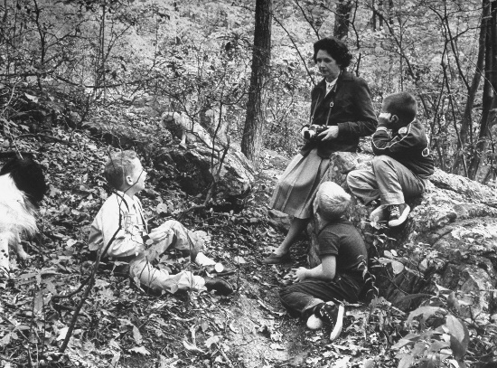 | The Personal Attacks on Rachel Carson as a Woman Scientist  This is Chapter 4 of the exhibition "Rachel Carson’s Silent Spring: A book that changed the world" by historian Mark Stoll.  www.environmentandsociety.org

Time Magazine, "Biology: Pesticides: The Price of Progress," https://time.com/archive/6873182/biology-pesticides-the-price-for-progress/

Monsanto Magazine, "The Desolate Year," https://iseethics.wordpress.com/wp-content/uploads/2011/12/monsanto-magazine-1962-the-desolate-yeart.pdf

BREAKOUT SESSION ASSIGNMENT:
Students will collaborate on creating a time machine (1962-era) podcast interview of Rachel Carson, the head of Monsanto and other selected experts and "persons on the street" that examines the debate about Rachel Carson and her work in the context of Gender, Sexuality and the Cold War.

